BANKING SYSTEM

Class Diagram:

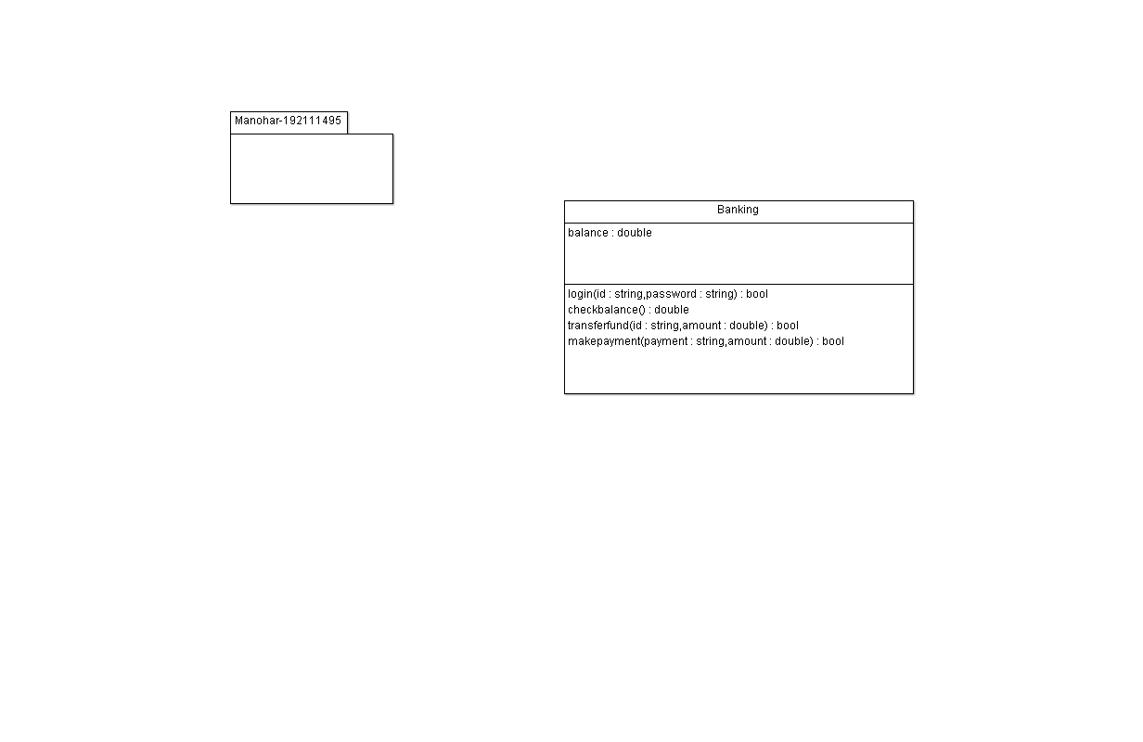

CODE:

#include "banking.h"

bool banking::login(string id, string password)

// don't delete the following line as it's needed to preserve source code of this autogenerated element

// section -84-18-50-8--7bfc112d:1859a22642f:-8000:00000000000009C3 begin

{

return false;

}

// section -84-18-50-8--7bfc112d:1859a22642f:-8000:00000000000009C3 end

// don't delete the previous line as it's needed to preserve source code of this autogenerated element

double banking::checkbalance()

// don't delete the following line as it's needed to preserve source code of this autogenerated element

// section -84-18-50-8--7bfc112d:1859a22642f:-8000:00000000000009C9 begin

{

return 0.0;

}

// section -84-18-50-8--7bfc112d:1859a22642f:-8000:00000000000009C9 end

// don't delete the previous line as it's needed to preserve source code of this autogenerated element

bool banking::transferfund(string id, double amount)

// don't delete the following line as it's needed to preserve source code of this autogenerated element

// section -84-18-50-8--7bfc112d:1859a22642f:-8000:00000000000009CB begin

{

return false;

}

// section -84-18-50-8--7bfc112d:1859a22642f:-8000:00000000000009CB end

// don't delete the previous line as it's needed to preserve source code of this autogenerated

{

return false;

}

// section -84-18-50-8--7bfc112d:1859a22642f:-8000:00000000000009CF end

// don't delete the previous line as it's needed to preserve source code of this autogenerated element